Procedural Programming

📌 Definition:
# Source: AI Source: Provided by: [Data Path: Persons Table -> ID Column: 1, Name_En Column: Motasem Essam] -> From: [Chatgpt (GPT‑5 Mini)] on [12/9/2025]
Procedural programming is a programming paradigm that focuses on step-by-step instructions to perform tasks using procedures (functions).

🧠 Simple idea:
# Source: AI Source: Provided by: [Data Path: Persons Table -> ID Column: 1, Name_En Column: Motasem Essam] -> From: [Chatgpt (GPT‑5 Mini)] on [12/9/2025]
Procedural = “Do this step, then this step…” 🪜

🔍 Key characteristics:
# Source: AI Source: Provided by: [Data Path: Persons Table -> ID Column: 1, Name_En Column: Motasem Essam] -> From: [Chatgpt (GPT‑5 Mini)] on [12/9/2025]
- 📋 Code is organized into functions/procedures
- 🔁 Program runs in a top-down sequence
- 🧩 Breaks problems into smaller steps
- 📦 Uses variables to store data
- ⚙️ Focuses on how to perform tasks

📌 Example (C language style):
# Source: AI Source: Provided by: [Data Path: Persons Table -> ID Column: 1, Name_En Column: Motasem Essam] -> From: [Chatgpt (GPT‑5 Mini)] on [12/9/2025]
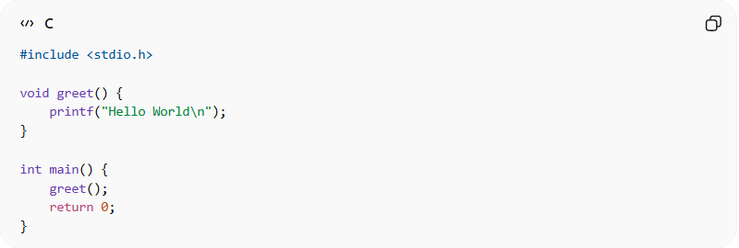
#include <stdio.h>

void greet() {
printf("Hello World\n");
}

int main() {
greet();
return 0;
}
👉 Here:
- greet() is a procedure (function)
- main() controls the flow step-by-step

⚙️ Real-world languages:
# Source: AI Source: Provided by: [Data Path: Persons Table -> ID Column: 1, Name_En Column: Motasem Essam] -> From: [Chatgpt (GPT‑5 Mini)] on [12/9/2025]
- 🟢 C
- 🟢 Pascal
- 🟢 Fortran
- 🟢 Older BASIC

🆚 Procedural vs OOP vs Functional
# Source: AI Source: Provided by: [Data Path: Persons Table -> ID Column: 1, Name_En Column: Motasem Essam] -> From: [Chatgpt (GPT‑5 Mini)] on [12/9/2025]
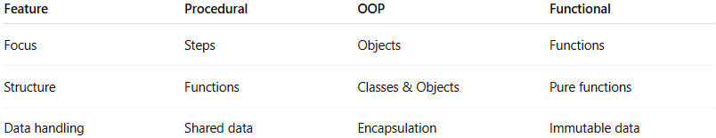
Feature | Procedural | OOP | Functional
Focus | Steps | Objects | Functions
Structure | Functions | Classes & Objects | Pure functions
Data handling | Shared data | Encapsulation | Immutable data

🎯 Summary:
# Source: AI Source: Provided by: [Data Path: Persons Table -> ID Column: 1, Name_En Column: Motasem Essam] -> From: [Chatgpt (GPT‑5 Mini)] on [12/9/2025]
Procedural programming solves problems by breaking them into step-by-step procedures, making it easy to understand and control the flow of execution.

